**LTE**

**Project: Uplink Implementation – Voice signal transmission using Simulink.**

**Contents**

Project Description: 2

Tools Used: 2

Details about uplink in LTE: 2

Implementation Details: 3

Execution: 5

Results: 5

Difficulties During implementation: 7

Conclusion: 7

## **Project Description:**

Implementation of LTE-Uplink and performing voice signal transmission using Simulink.

## **Tools Used:**

MATLAB 13.b/MATLAB 16.a; Simulink.

## **Details about uplink in LTE:**

SC-FDMA and orthogonal frequency division multiple access (OFDMA) are similar schemes except for a discrete Fourier transform which is added to the SC-FDMA transmission which changes the way how the data symbols are distributed over different subcarriers. The data symbols-subcarrier mapping is not one-to-one but instead each subcarrier carries a part from each data symbol transmitted at that time instant. The reason for the selection of SCFDMA comes mainly from its advantage to provide low a peak-to-average power ratio (PAPR) for the transmit waveform. This results in less power consumption in the mobile station compared to an OFDMA transmission.

The additional requirements which have made the SC-FDMA to shine are:

• Support for wide range of data rates.

• Sufficiently low PAPR of the transmitted waveform, to avoid high power consumption in

the mobile terminal (transmitter for the uplink).

• Enhanced uplink system throughput.

SC-FDMA and OFDMA are similar schemes except for the discrete Fourier transform (DFT) performed on the modulated data symbols in SC-FDMA.

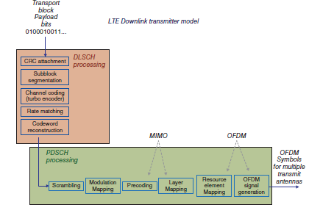

Fig.1

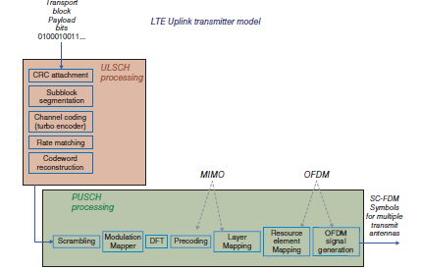

Fig 2

The above figures represent the uplink and downlink transmitter model.

One SC-FDMA frame constitutes 20 slots, each being 0.5 miliseconds long. Two slots are called a subframe or transmission time interval. The transmit signal in each slot is described by a resource grid with NRBNRBsc subcarriers and Nsymb SC-FDMA symbols.

The number of subcarriers for each resource block, NRBsc, is standardized as 12 for the LTE uplink. NRB depends on the uplink transmission bandwidth determined for that cell but should always be between 6 and 110. These numbers correspond to the smallest and largest uplink bandwidth.

The main components of LTE uplink physical channel is shown as below:

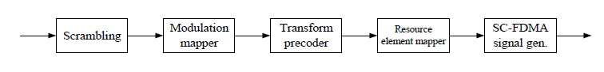

Fig.3

## **Implementation Details:**

The primary observation we have made was that we could implement the entire Uplink of LTE using the available codes for the downlink, but including the DFT functionality.

For the implementation of the DFT (Discrete Fourier Transform) we have used two MATLAB functions FFT and IFFT which are Fast Fourier transform and Inverse Fast Fourier transform respectively.

We have also included DFT and IDFT functions in separate scripts to perform the experiment.

The following are the snaps of the code that we have written for the DFT functionality.

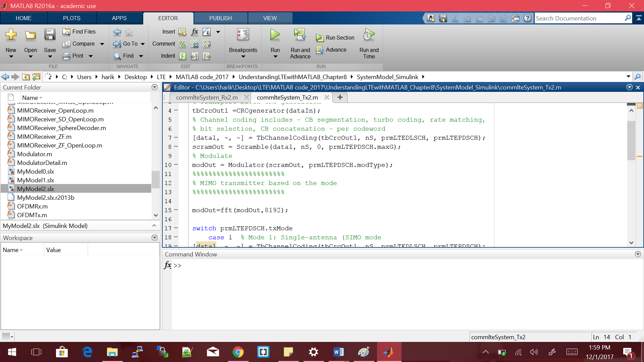

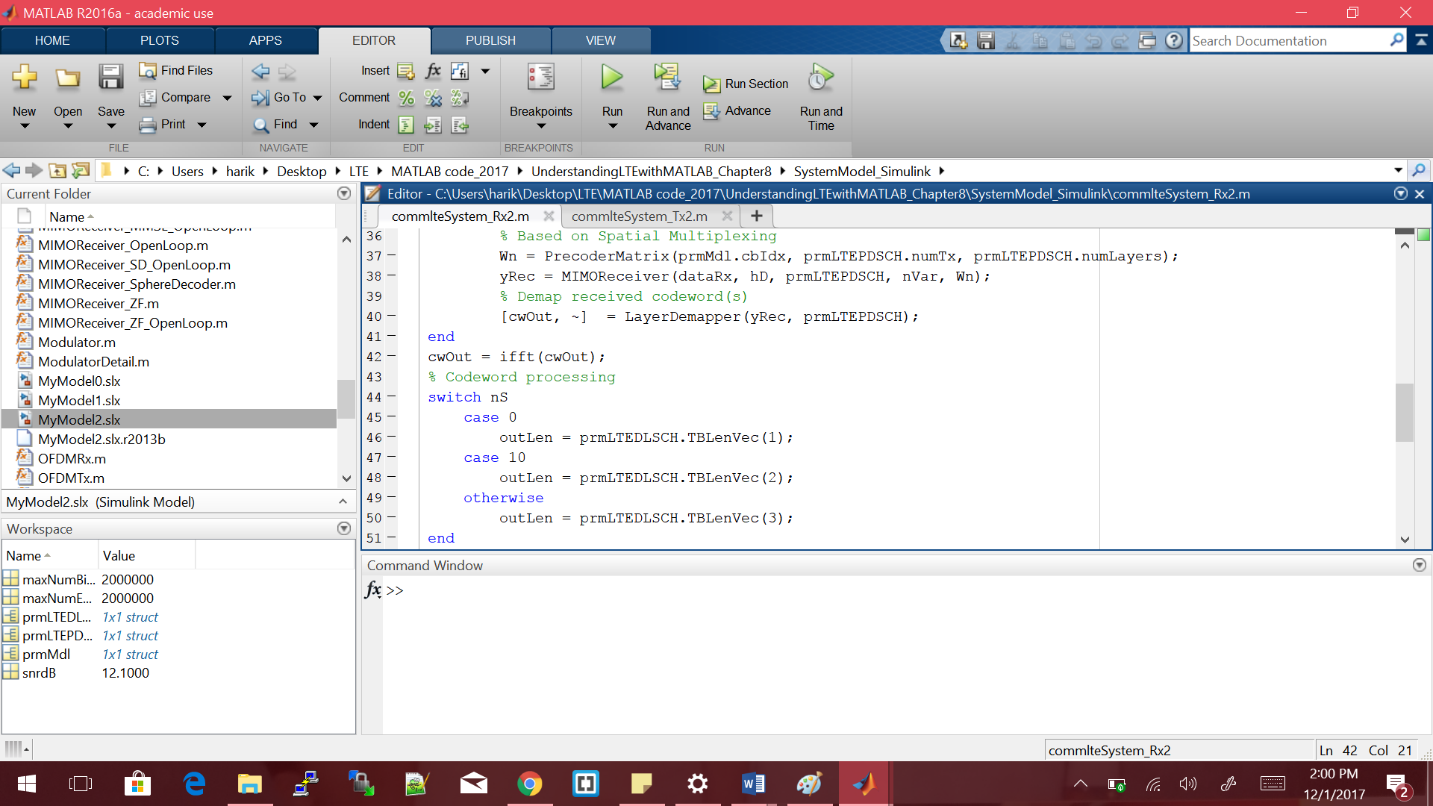

Using DFT and IDFT functions:

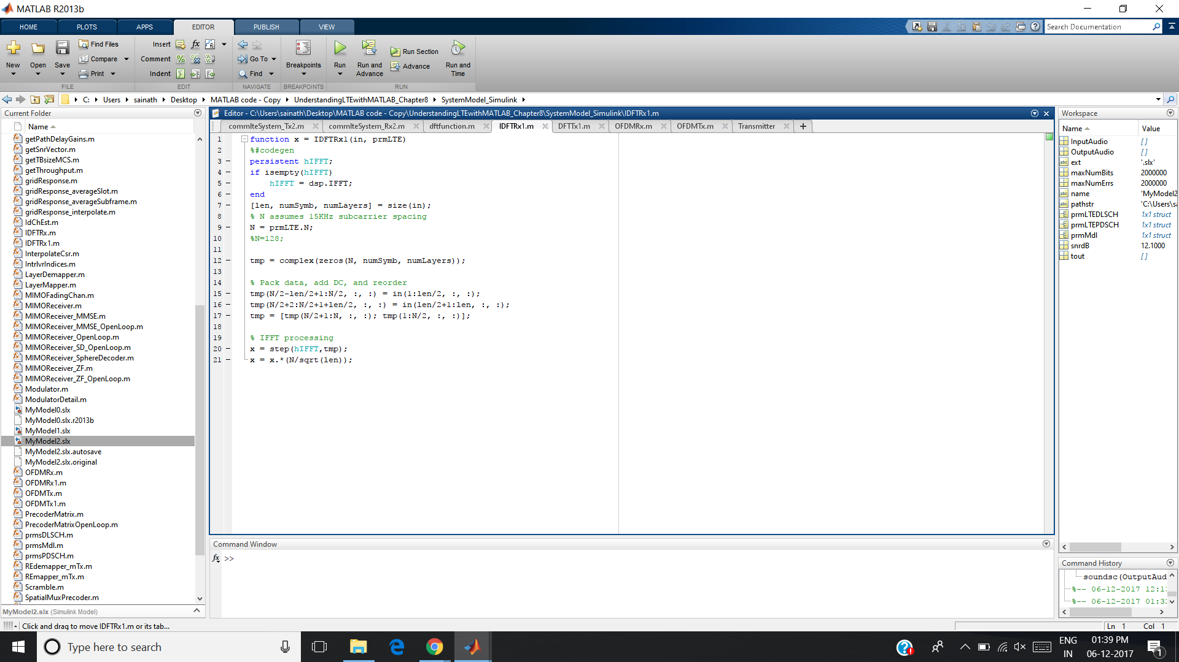

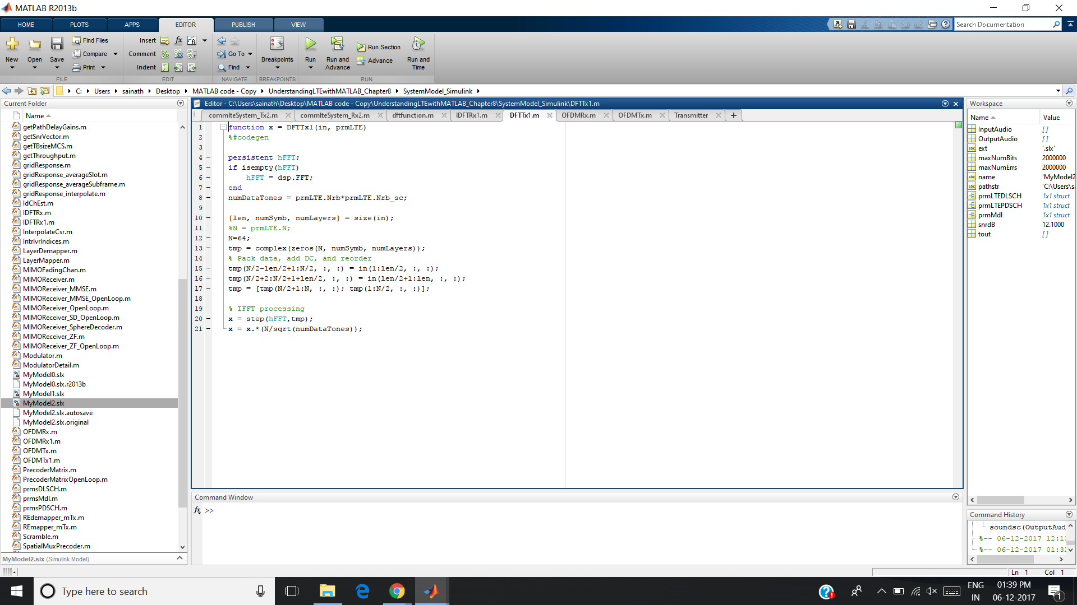

**System Model:**

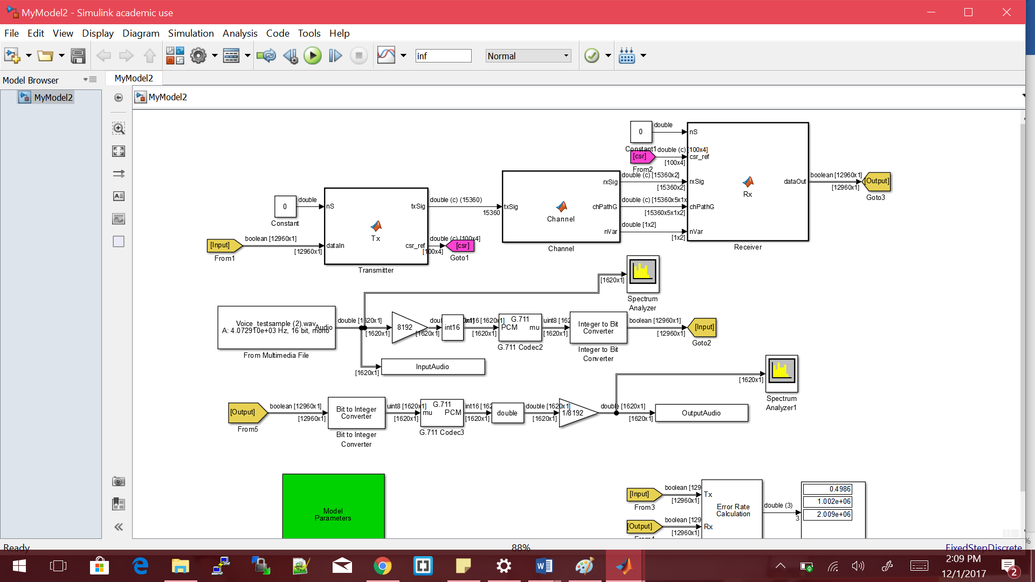

## **Execution:**

Run the Mymodel2 file of Simulink.

In the command window enter the commands:

* soundsc(InutputAudio,8000)
* soundsc(OutputAudio,8000)

To hear the input and output audio respectively.

## **Results:**

We have implemented this and tested for all modes of the LTE.

Spectrum images of transmitter and receiver.

Audio can be heard when you give the commands in the command line.

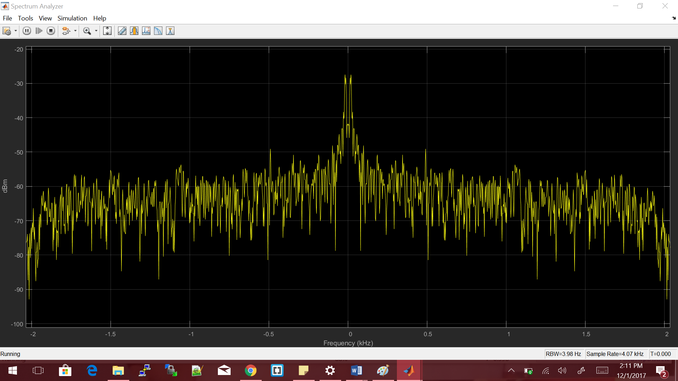

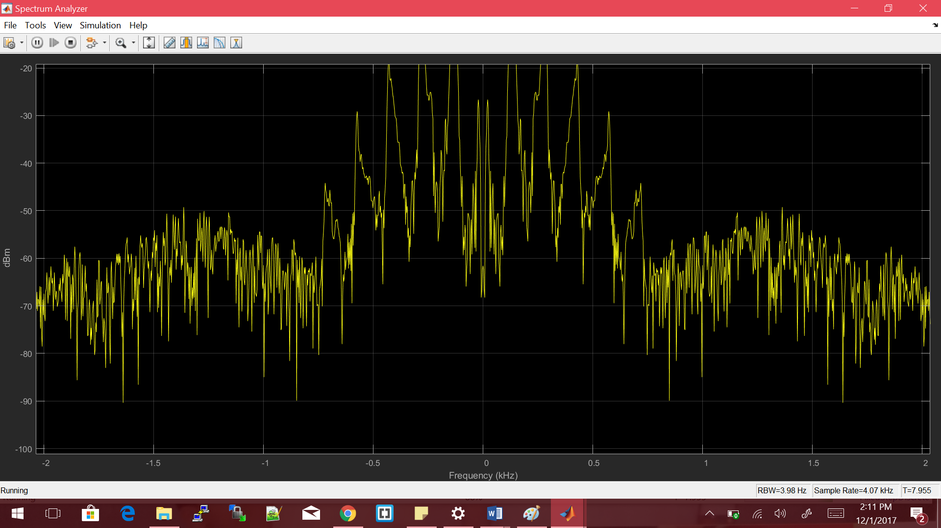

## **Difficulties During implementation:**

During the implementation trials we have faced difficulties which were related to the versions of the MATLAB and the communication toolbox. After several attempts we could observe that the MATLAB 13.b and MATLAB 16.a were most suitable for the implementation and hence used them.

From the result of DFT function we have observed that the DFT size should be greater than 1024 to avoid state flow errors which we faced in doing so we observed that results are produced with heavy noise and long duration of audio which is greater that the duration of the audio input.

## **Conclusion:**

We were able to get the voice only at random times and we are still working on figuring out why it is happening so. Though we were not successful in eliminating the noise in all cases, we think that more research and work on the implementation would help to obtain the desired output.

**References for our implementations:**

* Understanding LTE with MATLAB Textbook;
* Mathworks site: <https://www.mathworks.com/help/lte/ref/ltescfdmamodulate.html>
* <https://www.mathworks.com/matlabcentral/fileexchange/20454-simple-single-carrier-fdma--sc-fdma--simulator>